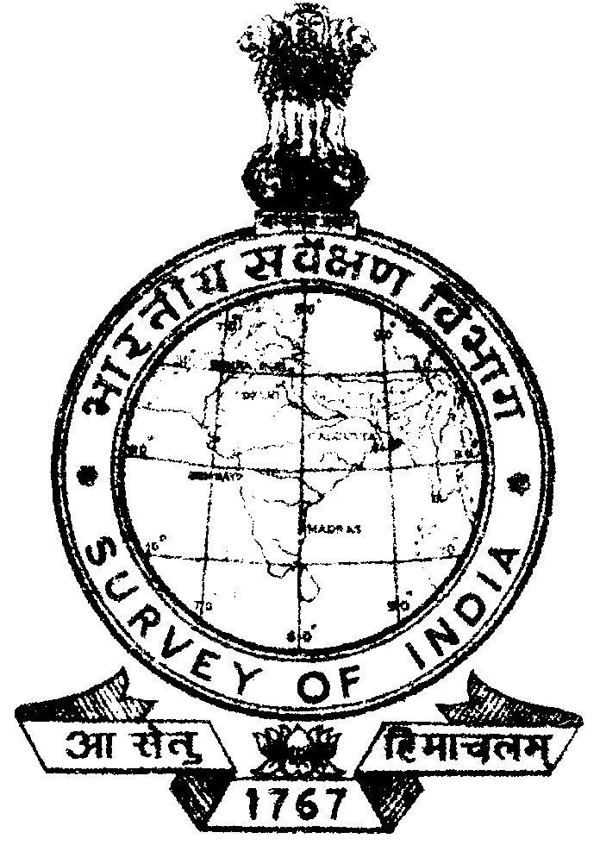

SURVEY OF INDIA
(MINISTRY OF SCIENCE AND TECHNOLOGY)
OFFICE OF THE DIRECTOR,
ANDHRA PRADESH GEO SPATIAL DATA CENTRE,
SURVEY OF INDIA
UPPAL, HYDERABAD.-500039
“NOTICE OF PENSION ADALAT”
No.AD-B 648/Adalat/APGDC dated 02/3/15
Date 08/4/2015 Time 11:30hrs
AT
APGDC CONFERENCE HALL

It is brought to the notice of all pensioners of APGDC that , a PENSION ADALAT shall be held on 8th April’2015 (time 11:30hrs) at APGDC Conference hall, Uppal, Hyderabad. Pensioners having grievances are requested to attend.

(K.K.GUPTA)
Superintending Surveyor
Chairman
PENSION ADALAT
Tel:-040-27201733

